Uber Data Assignment

Summary - Given data at hand presents the problem that Uber is facing, demand and supply gap due to unavailability of cabs at airports and too many cabs getting cancelled in the city in different time slots.

Analysis - Here are some findings from the data –

#1. There is no major effect of day on booking, cancellation, cabs unavailability and trip duration and demand – supply gap, probably because none are weekend. There are 5 different days given in the data ranging from Monday to Friday.

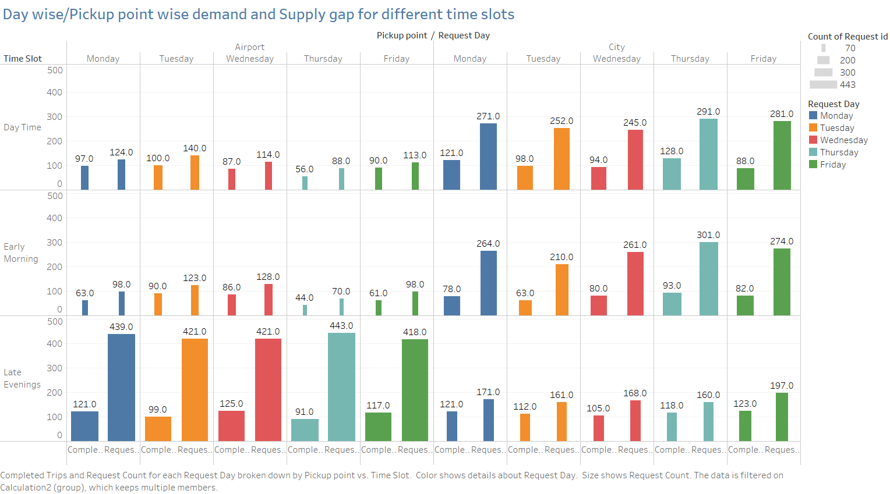

#2. Avg. trip duration is **<1 hour** for different timeslots and pickup points. Max. trip duration is between 1 – 2 hours.

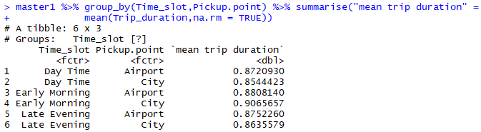

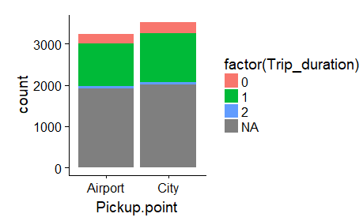

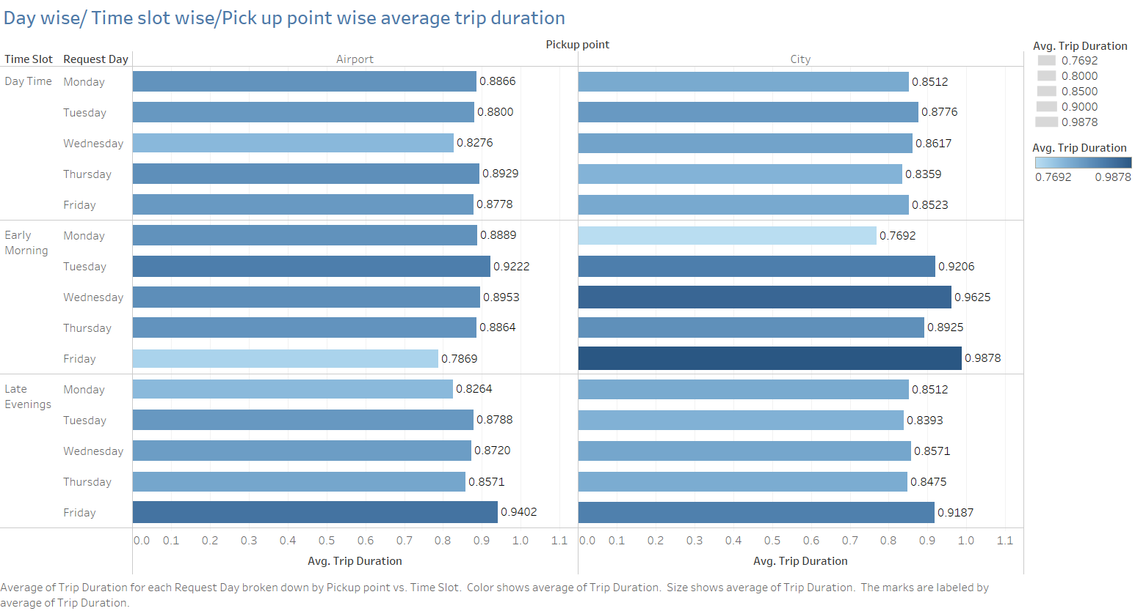

#3. From airport, most cabs are not available between – 4 o’clock in the evening to 11 o’clock in the night. On an average ~300 cabs are not available in this time span.

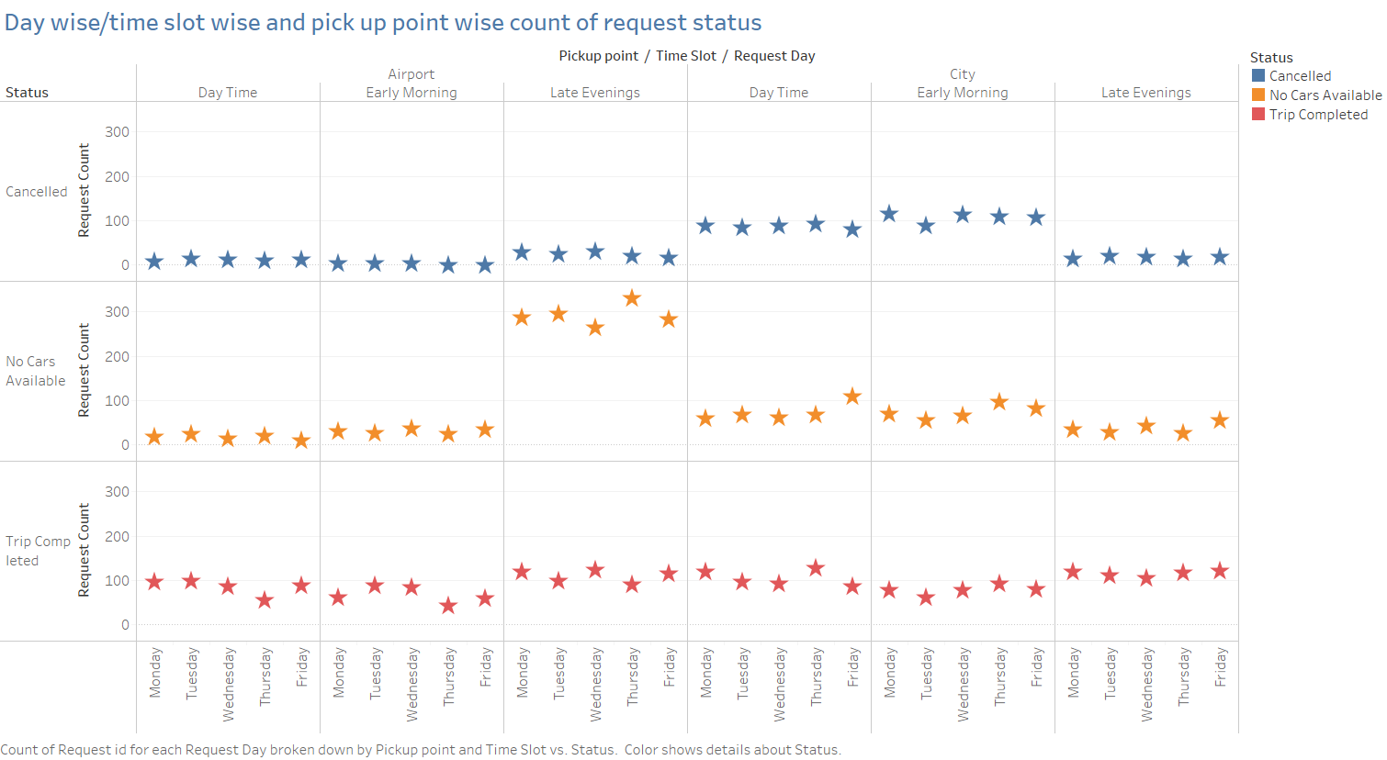

#4. From city most cabs get cancelled in the between – 12 AM in the night to 3 PM in the evening. On an average ~100 cabs get cancelled in this time period.

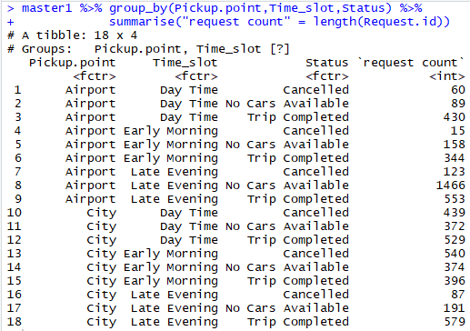

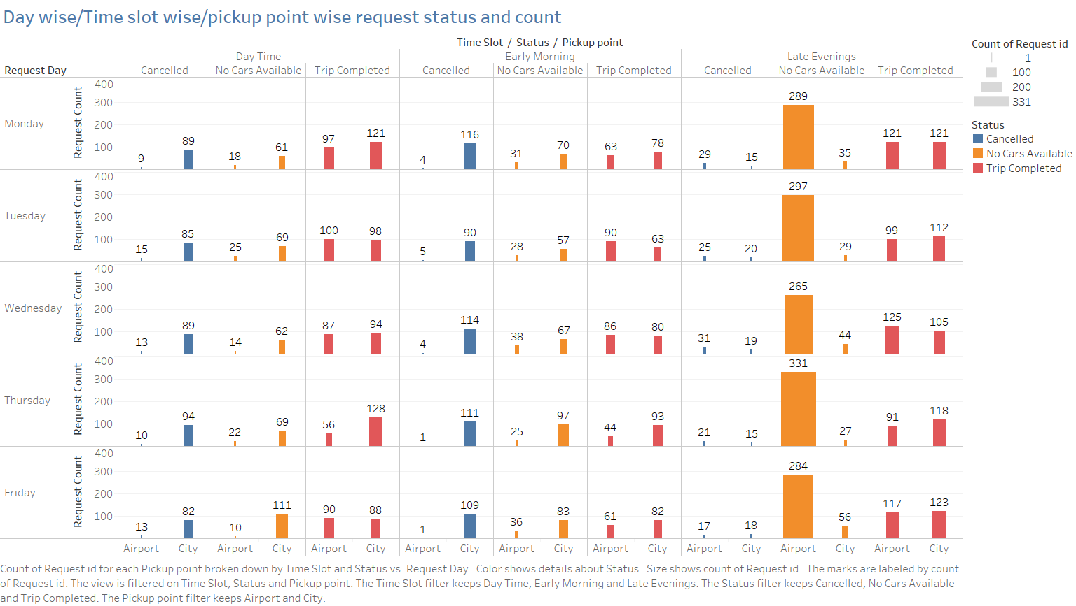

Conclusion –There is a gap in demand and supply as in cities cabs get cancelled during early morning and day time whereas cabs are not available in the late evening from airports.

Prime reason behind this could be many cabs get cancelled from city in the day time and early morning because there may be traffic on airport route or they don’t get return booking easily. Whereas at airports most cabs show unavailable at late night, because cabs are present in the city and they don’t want to come to the airport because of less frequency of flights, resulting in increased waiting time for return trip to city.

Recommendations – Uber should reduce some cabs from city in the early morning and day time and allot them to airports plus it should reserve some cabs in spare at the airports in the late evenings.